Meridional Great Circle
# Source: AI Source: Provided by: [Data Path: Persons Table -> ID Column: 1, Name_En Column: Motasem Essam] -> From: [ChatGPT] on [7/25/2026]
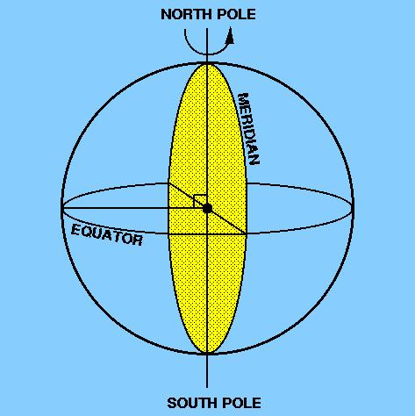
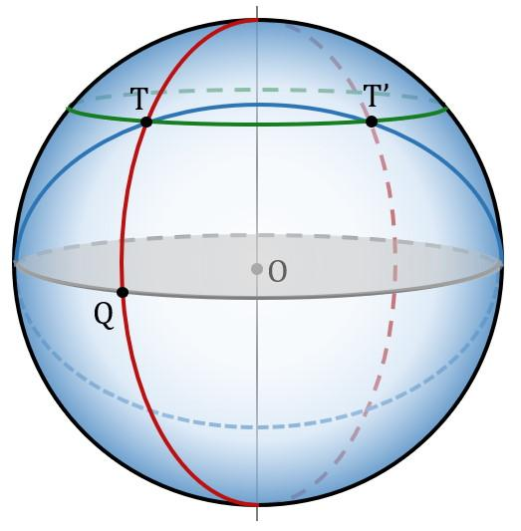
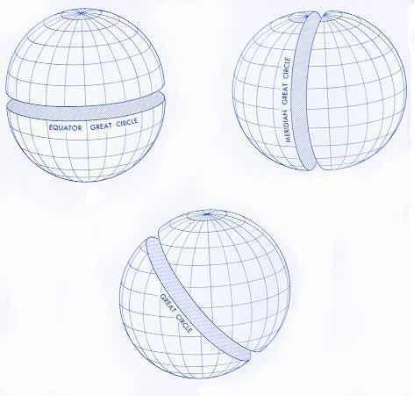

Definition
# Source: AI Source: Provided by: [Data Path: Persons Table -> ID Column: 1, Name_En Column: Motasem Essam] -> From: [ChatGPT] on [7/25/2026]
A meridional great circle is a great circle on a sphere that passes through the two poles defined by a chosen rotational axis. It is formed by the intersection of the sphere's surface with a meridian plane that contains the rotational axis and passes through the sphere's center.
On Earth, a meridional great circle passes through the North Pole and South Pole. A complete meridian great circle includes a meridian and its opposite meridian; this is why a single line of longitude from pole to pole is only half of the corresponding great circle.

Simple Definition
# Source: AI Source: Provided by: [Data Path: Persons Table -> ID Column: 1, Name_En Column: Motasem Essam] -> From: [ChatGPT] on [7/25/2026]
A meridional great circle is a circle around a sphere that passes through both poles and has its center at the sphere's center.
It is a great circle because its plane passes through the sphere's center.

Geometric Representation
# Source: AI Source: Provided by: [Data Path: Persons Table -> ID Column: 1, Name_En Column: Motasem Essam] -> From: [ChatGPT] on [7/25/2026]
Consider a sphere with center $O$, radius $R$, and a rotational axis passing through the North Pole $N$ and South Pole $S$.
The meridional great circle has these elements:
- Center: $O$, the center of the sphere.
- Radius: $R$, equal to the sphere's radius.
- Meridian plane: A plane passing through $O$, $N$, and $S$.
- Poles: The two opposite points $N$ and $S$ on the sphere's surface.
- Equatorial intersections: The great circle crosses the equatorial great circle at two opposite points.
- Circumference: $2πR$.
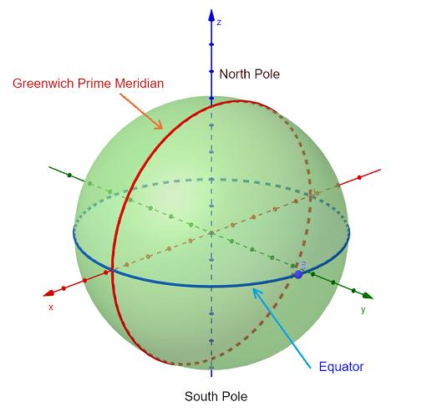

Mathematical Representation
# Source: AI Source: Provided by: [Data Path: Persons Table -> ID Column: 1, Name_En Column: Motasem Essam] -> From: [ChatGPT] on [7/25/2026]
Suppose the sphere is centered at the origin with radius $R$, and its rotational axis is the $z$-axis.
The sphere equation is
$$x^{2}+y^{2}+z^{2}=R^{2}$$
Choose the meridian plane $y=0$. Its intersection with the sphere is the meridional great circle:
$$\boxed{x^{2}+z^{2}=R^{2}, y=0}$$
The two poles are
$$N=\left(0,0,R\right), S=\left(0,0,-R\right)$$
The meridional great circle has radius $R$ and diameter $2R$, just like every other great circle on the same sphere.
General orientation
A meridian plane can be rotated around the $z$-axis. One possible equation is
$$y\cos{θ}-x\sin{θ}=0$$
where $θ$ determines the orientation of the plane. Each such plane contains the rotational axis and produces a meridional great circle.

Formulas
# Source: AI Source: Provided by: [Data Path: Persons Table -> ID Column: 1, Name_En Column: Motasem Essam] -> From: [ChatGPT] on [7/25/2026]
Let $R$ be the sphere's radius.
Radius of the great circle
$$r=R$$
Diameter
$$d=2R$$
Circumference
$$C=2πR$$
Area of the enclosed circular disk
$$A=πR^{2}$$
Length of a semicircular arc between the poles
$$L=πR$$
The area formula refers to the flat disk bounded by the great circle, not the curved surface area of the sphere.

Key Characteristics
# Source: AI Source: Provided by: [Data Path: Persons Table -> ID Column: 1, Name_En Column: Motasem Essam] -> From: [ChatGPT] on [7/25/2026]
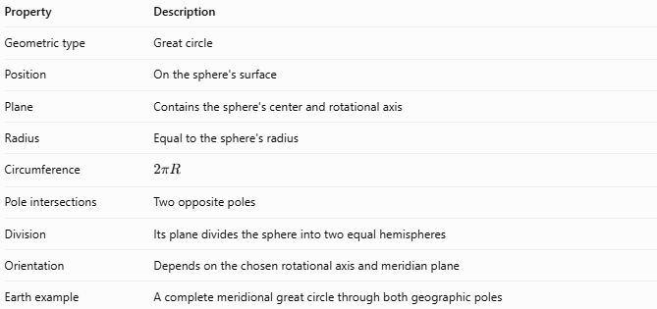
Property | Description
Geometric type | Great circle
Position | On the sphere's surface
Plane | Contains the sphere's center and rotational axis
Radius | Equal to the sphere's radius
Circumference | $$2πR$$
Pole intersections | Two opposite poles
Division | Its plane divides the sphere into two equal hemispheres
Orientation | Depends on the chosen rotational axis and meridian plane
Earth example | A complete meridional great circle through both geographic poles

Worked Example
# Source: AI Source: Provided by: [Data Path: Persons Table -> ID Column: 1, Name_En Column: Motasem Essam] -> From: [ChatGPT] on [7/25/2026]
Problem: A sphere has a radius of $10\text{ cm}$. Find the circumference of its meridional great circle and the length of the shorter arc from one pole to the other along that circle.
Given:
$$R=10\text{ cm}$$
Step 1 — Circumference
$$C=2πR=2π\left(10\right)$$
$$\boxed{C=20π\text{ cm}≈62.83\text{ cm}}$$
Step 2 — Pole-to-pole arc length
The shorter arc between opposite poles is a semicircle:
$$L=\frac{C}{2}=πR$$
$$\boxed{L=10π\text{ cm}≈31.42\text{ cm}}$$
Thus, the complete great circle measures approximately $62.83\text{ cm}$, and the pole-to-pole semicircular arc measures approximately $31.42\text{ cm}$.

Meridional Great Circle vs. Equatorial Great Circle
# Source: AI Source: Provided by: [Data Path: Persons Table -> ID Column: 1, Name_En Column: Motasem Essam] -> From: [ChatGPT] on [7/25/2026]
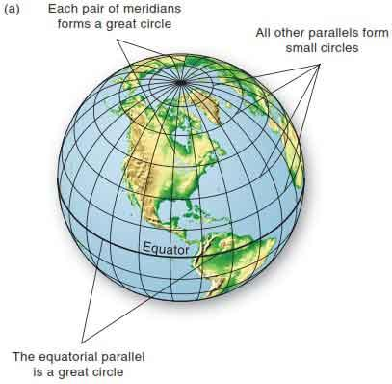
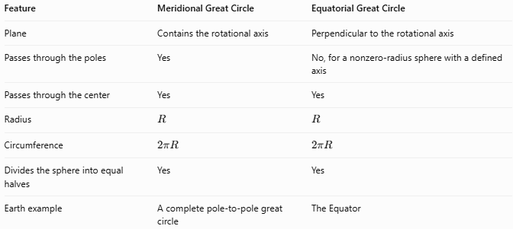
Feature | Meridional Great Circle | Equatorial Great Circle
Plane | Contains the rotational axis | Perpendicular to the rotational axis
Passes through the poles | Yes | No, for a nonzero-radius sphere with a defined axis
Passes through the center | Yes | Yes
Radius | $$R$$ | $$R$$
Circumference | $$2πR$$ | $$2πR$$
Divides the sphere into equal halves | Yes | Yes
Earth example | A complete pole-to-pole great circle | The Equator

Meridian vs. Meridional Great Circle
# Source: AI Source: Provided by: [Data Path: Persons Table -> ID Column: 1, Name_En Column: Motasem Essam] -> From: [ChatGPT] on [7/25/2026]
These terms are closely related but should be distinguished.
- Meridian: In geography, commonly the pole-to-pole line of longitude along a specified half of a great circle.
- Meridional great circle: The complete great circle, including both opposite pole-to-pole arcs.
- Meridian plane: The plane passing through the sphere's center and rotational axis that contains the great circle.
A meridian plane intersects the sphere in a full great circle, not just one semicircular arc.

Applications
# Source: AI Source: Provided by: [Data Path: Persons Table -> ID Column: 1, Name_En Column: Motasem Essam] -> From: [ChatGPT] on [7/25/2026]
- Geography: Understanding lines of longitude and the relationship between meridians and great-circle routes.
- Navigation: Studying shortest paths between points on a spherical model of Earth.
- Astronomy: Defining great circles through the poles of a celestial body's coordinate system.
- Mathematics: Studying spherical distances, arcs, and intersections of planes with spheres.
- Computer graphics: Drawing spherical coordinate grids and meridian lines.

Key Points
# Source: AI Source: Provided by: [Data Path: Persons Table -> ID Column: 1, Name_En Column: Motasem Essam] -> From: [ChatGPT] on [7/25/2026]
- A meridional great circle passes through both poles defined by a chosen axis.
- It is formed by intersecting the sphere with a meridian plane.
- Its plane passes through the sphere's center.
- Its radius equals the sphere's radius.
- Its circumference is $2πR$.
- A single pole-to-pole meridian arc is a semicircle; the complete meridional great circle includes both arcs.

Conclusion
# Source: AI Source: Provided by: [Data Path: Persons Table -> ID Column: 1, Name_En Column: Motasem Essam] -> From: [ChatGPT] on [7/25/2026]
The meridional great circle is a great circle whose plane contains a sphere's center and chosen rotational axis. It passes through both poles and divides the sphere into two equal hemispheres. On Earth, meridional great circles provide the geometric foundation for understanding meridians of longitude and spherical navigation.

